AE 313 Project

Orbit Transfer Mission from LEO-GEO

Students Name:

Jie Bao

Nicholas Ngo Syuan Yaw

Yuan Zhao

Submitted on April 25, 2018

Instructor Name:

**Dr. Morad Nazari**

Embry-Riddle Aeronautical University

Daytona Beach, FL32114

Orbit Transfer Mission from LEO-GEO

Jie Bao,[1] and [Nicholas Ngo Syuan Yaw](https://erau.instructure.com/courses/75037/users/110884)[2]

[Yuan Zhao](https://erau.instructure.com/courses/75037/users/161680)[3]

*Embry-Riddle Aeronautical University, Daytona Beach, Florida, 32114, United-States*

**Following the effective launch of the Falcon 9, SpaceX has successfully stationed the Koreasat-5A into a circular LEO parking orbit. The main objective of this project is to understand how a payload is delivered to an orbit oriented on a different inclination angle from the starting orbit. This report discusses possible plane change maneuvers to transfer the payload from the parking orbit to a circular GEO. The bi-elliptical transfer with split-plane change and the Hohmann split-plane change maneuver are the two methods to be used for this analysis. However, as propellant fuel is limited, we will demonstrate the "optimal" plane change trajectory for the case of this mission.**

**RESULTS (USING MATLAB & STK) & FINDINGS**

1. **Nomenclature**

*A* = amplitude of oscillation

*a* = cylinder diameter

*Cp*= pressure coefficient

*Cx* = force coefficient in the *x* direction

*Cy* = force coefficient in the *y* direction

c = chord

d*t* = time step

*Fx* = *X* component of the resultant pressure force acting on the vehicle

*Fy* = *Y* component of the resultant pressure force acting on the vehicle

*f, g* = generic functions

*h* = height

*i* = time index during navigation

*j* = waypoint index

*K* = trailing-edge (TE) nondimensional angular deflection rate

1. **Introduction**

As of 2017, there are over 4 billion internet users[4] around the world. In addition, the demand for faster and larger coverage keeps increasing year after year. The Asian market is the largest and is roughly composed of around 48%[5] of the total internet user population. As a matter of fact, in South Korean, nine person out of ten[6] have access to high-speed internet services - an average speed of 28.6Mbit/s[7]. The global success of widespread internet access in South Korea is the result of the government's early actions and policy making ability (notably the Korea Network Committee - KNC)[8]. This has helped develop the country's internet industry competitive advantage. For example, in the early 1980's, a group of universities has collaborated to create Korea's first Internet system, SDN - System Development Network[9]. Moreover, these large cluster of research centers led to the creation of Internet innovation conferences, such as the Korea Internet Conference - KRNET.

To satisfy this ever growing demand for fast internet services, KT Corporation is one of the many large internet providers in South Korea. In 2014, KT have reached an agreement with Europe's largest satellite manufacturer, Thales Alenia Space. The contract signed is for the construction of two telecommunication satellite, Koreasat-5A and Koreasat-7A, and fulfill the need to provide Internet access[10].

The 3,500 kg Koreasat-5A satellite, equipped with Ku-band transponders, was launched on Monday, October 30th at 3:34 p.m. EST, from Cape Canaveral at NASA's Kennedy Space Center. SpaceX' falcon 9 rocket was used for the insertion of the payload into the LEO parking orbit, at an altitude of 284 km and with an inclination angle of 28.5 degrees to the equator. This orbit insertion is fixed, so our study will start following the LEO entry parking orbit.

This project will use impulsive orbit transfers to achieve the final target orbit. For this reason, we will consider the Hohmann split-plane change or the bi-elliptic transfer with split plane change. The first transfer orbit for the Koreasat-5A is a supersynchronous elliptical transfer orbit, with an apogee of 50188 km, 284 km perigee, and an inclination of 22 degrees to the equator. Finally The payload must reach the final orbit, it shall be a 35,786 km circular geostationary equatorial orbit -GEO with zero degree inclination to the equator.

Finally, the last activity of the project consist of interpreting and comparing the results from the two previously stated methods. In addition, we will determine what is the most efficient split -plane change between the second and final maneuvers to reduce the total velocity change. Therefore, we can choose the maneuver that requires the lowest amount of propellant burn.

1. **Impulsive Orbit Transfers**

In this project, the impulsive orbit maneuvers are based upon the theory of Hohmann and bi-elliptic transfers. In addition, inclination change are also considered into the total ΔV as the initial orbit must change from 28.5o to 0o.

In the Hohmann transfer the body (or the satellite), receives a brief change in its velocity direction and magnitude. The "impulsive" maneuver is delivered tangentially at the apse line of the celestial body's initial orbit. The tangential burn lasts for an infinitesimally small amount of time.

$$\frac{∆m}{m}=1-e^{{-ΔV}/{I_{sp}*g_{0}}}$$

$$m=mass of spacecraft before burn, kg ΔV =change in velocity magnitude, \frac{km}{ s}$$

$I_{sp}= specific impulse of the propelants, s$ $g_{0}=standard acceleration of gravity, \frac{km}{s^{2}}$

The satellite will there on move onto a new orbit, the travel ellipse will approach the circular target orbit with an undesired velocity magnitude. Therefore, a new impulsive maneuver is delivered to correct the satellite velocity and carry on the correct target orbit.

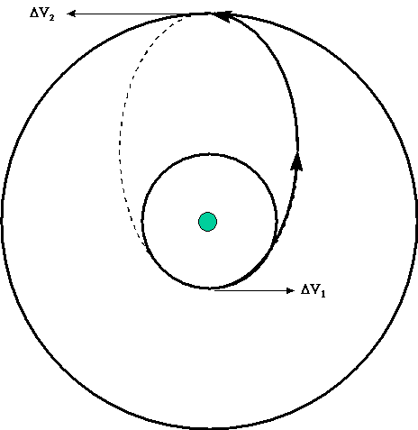[11]

This method offers the great advantage of only using two burns, hence, only two ΔV burn are required. Resulting in the most energy-efficient coplanar maneuver. It is valuable to understand that the energy requirement from a smaller orbit to a larger orbit will always be higher. This is explained through the semimajor axis (a) in the energy equation for the ellipse and the circle.

$$ε=\frac{v^{2}}{2}-\frac{μ}{r}$$

$$ε=-\frac{μ}{2a}$$

$ε=specific energy, \frac{{km}^{2}}{s^{2}} μ=gravitational parameter, \frac{{km}^{3}}{s^{2}}$ $a=semi major axis, km$

$$v=velocity, \frac{km}{s} r=position magnitude, km$$

By combining both equation, we can derive an equation that will enable us to determine the velocity of the satellite at specific position on the orbit.

$$v=\sqrt{2*μ*(\frac{1}{r}-\frac{1}{r_{a}+r_{p}})}$$

$$r_{a}=radius of apoapsis, km r_{p}=radius of periapsis, km$$

Taking the absolute value difference between the two velocities at the same point, results in the ΔV. The strategy is to set accordingly both the radius of apoapsis and periapsis to their respective orbit.

The second method is the bi-elliptic Hohmann transfer. Using this transfer, the satellite will reach its target destination after completing two different coaxial semiellipses. Likewise, the tangential burn are introduced at the intersection where the ellipses are tangent to their respective circular orbits. In contrast to the original Hohmann transfer, three ΔV burn are required:

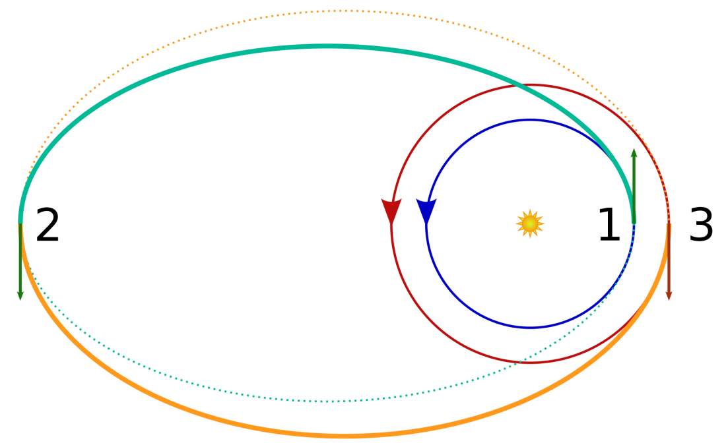

Looking back, we may by inspection reason that burn 1 & 2 increasing the velocity of the spacecraft. In fact, the semimajor axis is increasing during that transition of orbits, thus the energy demand is also increasing.

$$ε=-\frac{μ}{2a}$$

$ε_{i}<ε_{t,1} ε_{t,1}<ε_{t,2} ε_{t,2}>ε_{f}$

At the last location, three, the second semielliptic orbit is docking in a lower energy circular orbit (due again, to the semimajor axis) . Therefore, the spacecraft has to decrease its approaching velocity. However, the actual transfer orbits of the Koreasat-5A are not coplanar, so it is imperative to consider the plane change.

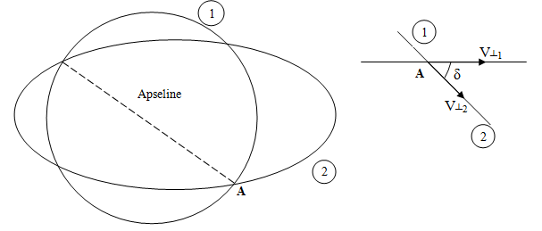



From the above figure, we may by inspection set up the equation of ΔV necessary for a plane change. We first state the radial and the transverse component of the velocities at point A.

$${\overline{V}}_{1}=V_{r,1}∙ {\hat{u}}_{r,1}+V_{,1┴}∙ {\hat{u}}_{┴,1}$$

$${\overline{V}}_{2}=V_{r,2}∙ {\hat{u}}_{r,2}+V_{┴,2 }{∙ \hat{u}}_{┴,2}$$

$$V_{r}=radial velocity,\frac{km}{s} {\hat{u}}_{r}=radial unit vector, km$$

$$V_{┴ }=transverse velocity, \frac{km}{s} {\hat{u}}_{┴}=radial unit vector, km$$

At the common location A, the radial direction is the same as the common apseline,

$${\overline{V}}_{2}-{\overline{V}}_{1}=ΔV=\left(V_{r,2}-V_{r,1}\right){ \hat{u}}_{r}+V_{┴,2 }∙{ \hat{u}}_{┴,2}+V_{┴,2 }∙{ \hat{u}}_{┴,2}$$

As we know, whether the it is the periapsis or apoapsis, the radial component will have no value.

$$V_{r,1,2}=0 V_{┴,1 }=V_{1} V_{┴,2 }=V_{2 }$$

The simultaneous orbit split-plane change equation is:

$$ΔV=\sqrt{V_{1}^{2}+V_{2}^{2}-2V_{1}V_{2}cosδ}$$

$$δ=Inclination difference, degrees °$$

Notice that there is no more vectors. In general, the most efficient plane change is done on the apseline or more precisly at the apoapsis. The velocities are slowest at that point. The further away the better.

The figure below from the book reveals when should the bi-elliptical maneuver should be used over the Hohmann transfer. The rB stands for the transfer orbit periapsis and the rC stands for the final radius of the target orbit.

citation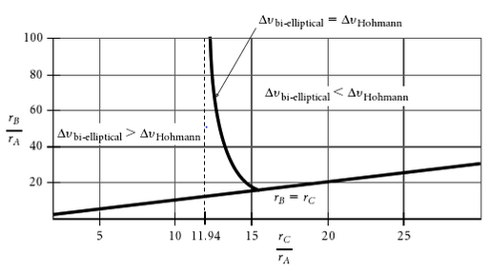

1. **Analysis through Systems Tool Kit (STK) by AGI**

STK has been considered as a powerful tool for modelling missions with accurate celestial body models. The teams main purpose of using the STK is to provide a base line comparison model to simple calculations which omit perturbations with paramount efficiency. STK has shown its potential to create custom views and images while simulate past events and obtain results in multiple forms such as graphs or tables. The following paragraph will provide an overview of the pages to come in this section.

The STK process is broken down into three main parts; Modelling of the Mission Control Sequence (Section 1), Table of Results (Section 2) and a 3D model (Section 3) of the mission. In Section 1, readers will dive into the steps taken to model each maneuver for the whole mission sequence. Each sequence is color coded and a ground track figure is provided for the ease of following. In Section 2, a tabulated table will be listing some major key results obtain for each model. In Section 3, three 3D models of the sequence including oblique, side and top views will be provided for reference.

The final section titled “Footnotes by Creator” will be discussing the results obtained and the challenged faced while using STK.

**Bi-elliptic Transfer**

1. Building the Mission Control Sequence (MCS)
2. LEO (Initial State Parking Orbit)

* Semi-major Axis = 6662.15km
* Eccentricity = 0
* Inclination = 28.5°
* Propagate LEO Orbit at Ascending Node

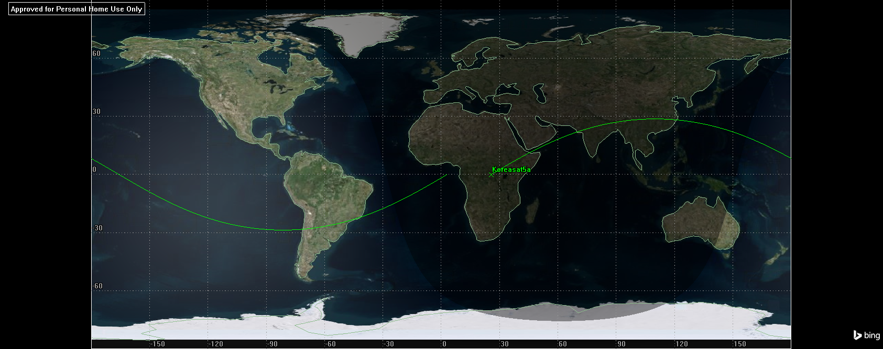

1. Supersynchronous Elliptical Transfer Orbit 1 (Target Orbit)

* Delta V1 (Velocity & Inclination Change Maneuver)
* Propagate to Transfer Orbit 1 at Apoapsis

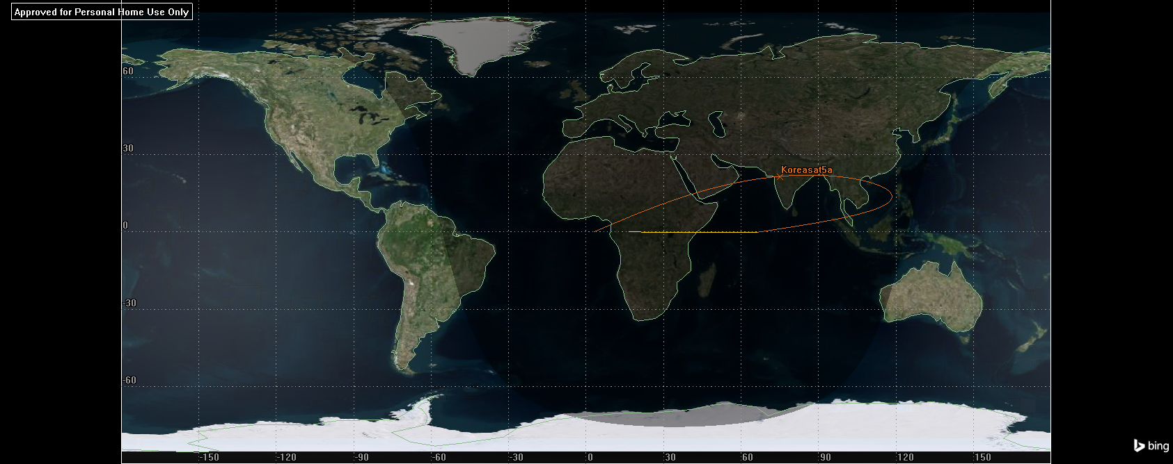

1. Supersynchronous Elliptical Transfer Orbit 2 (Target Orbit)

* Delta V2 (Velocity & Inclination Change Maneuver)
* Propagate to GEO Orbit at Epoch
* Propagate to Transfer Orbit 2 at Periapsis

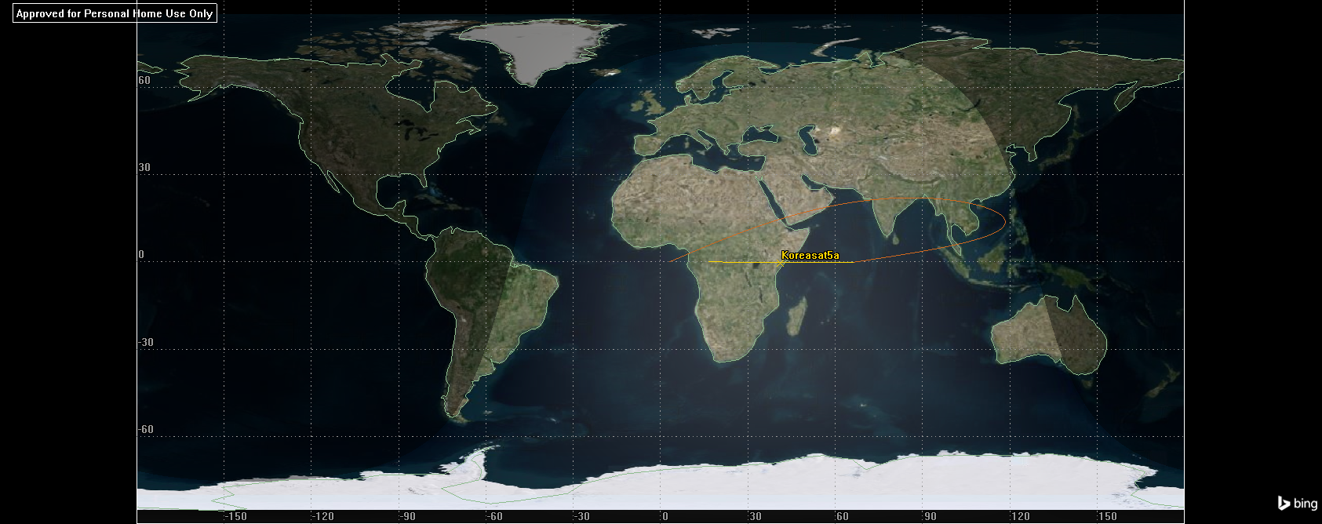

1. GEO (Final Orbit)

* Delta V3 (Velocity Change Maneuver)
* Propagate to GEO Orbit at Epoch

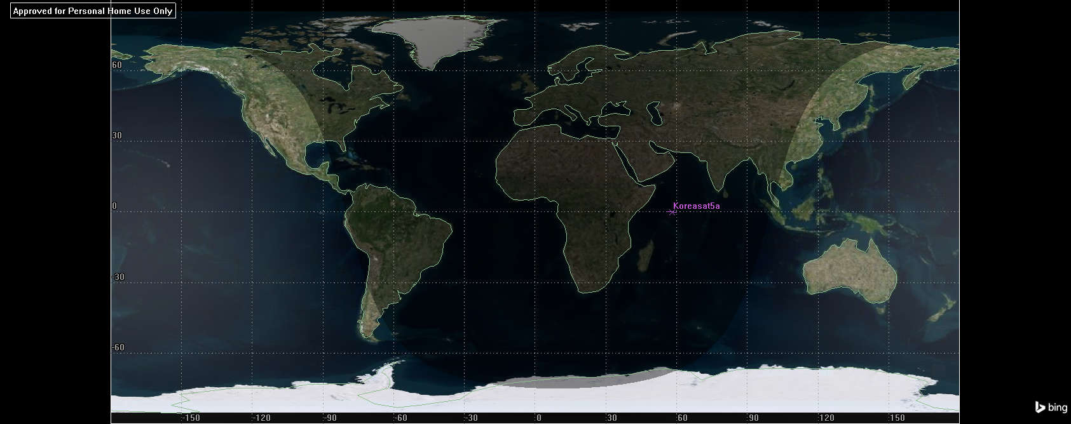

1. Table of Results

|  |  |  |  |  |  |
| --- | --- | --- | --- | --- | --- |
|  | **Maneuver Number** | **Segment** | **Est./Act. Finite Burn Duration (sec)** | **Delta V (m/sec)** | **Fuel Used (kg)** |
|  | 1 | SSync_Transfer_1.Delta_V1_(Combined) | 19875.105 | 2801.68519 | 3377.828 |
|  | 2 | SSync_Transfer_2.Delta_V2_(Combined) | 4728.06 | 1399.94888 | 803.547 |
|  | 3 | GEO.Delta_V3 | 847.05 | 340.109757 | 143.958 |
| **Global Statistics** |  |  |  |  |  |
| Total Est./Act. Finite Burn Duration |  |  | 25450.215 |  |  |
| Total Delta V |  |  |  | 4541.74382 |  |
| Total Fuel Used |  |  |  |  | 4325.333 |

1. 3D Graphics (Overview)

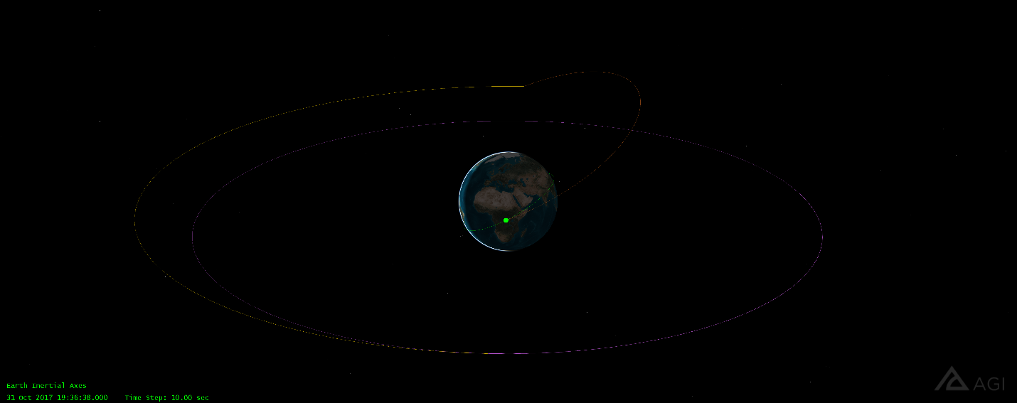

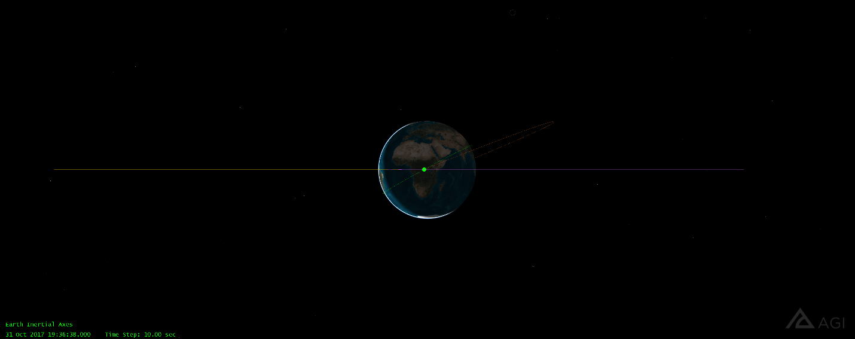

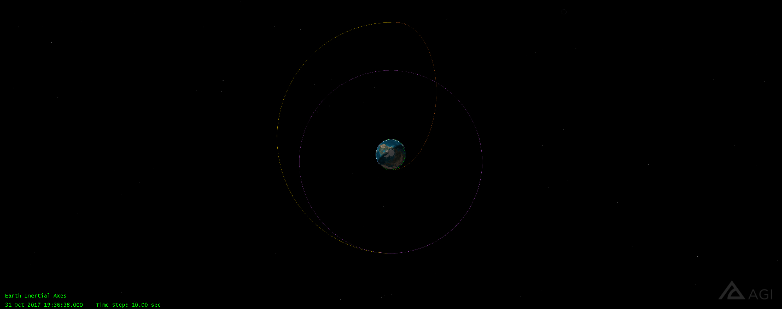

**Hohmann Split Plane Change**

1. Building the Mission Control Sequence (MCS)
2. LEO (Initial State Parking Orbit)

* Semi-major Axis = 6662.15km
* Eccentricity = 0
* Inclination = 28.5°
* Propagate LEO Orbit at Ascending Node

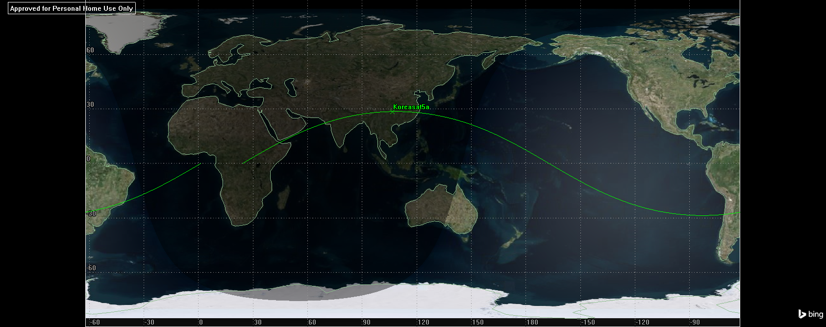

1. Transfer Orbit (Target Orbit)

* Delta V1 (Velocity Change Maneuver)
* Propagate to Transfer Orbit at Apoapsis

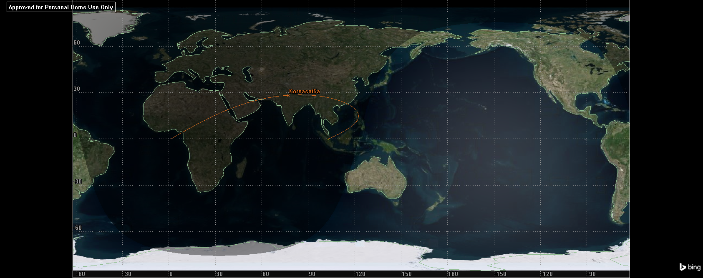

1. GEO (Final Orbit)

* Delta V2 (Velocity & Inclination Change Maneuver)
* Propagate to GEO Orbit at Epoch

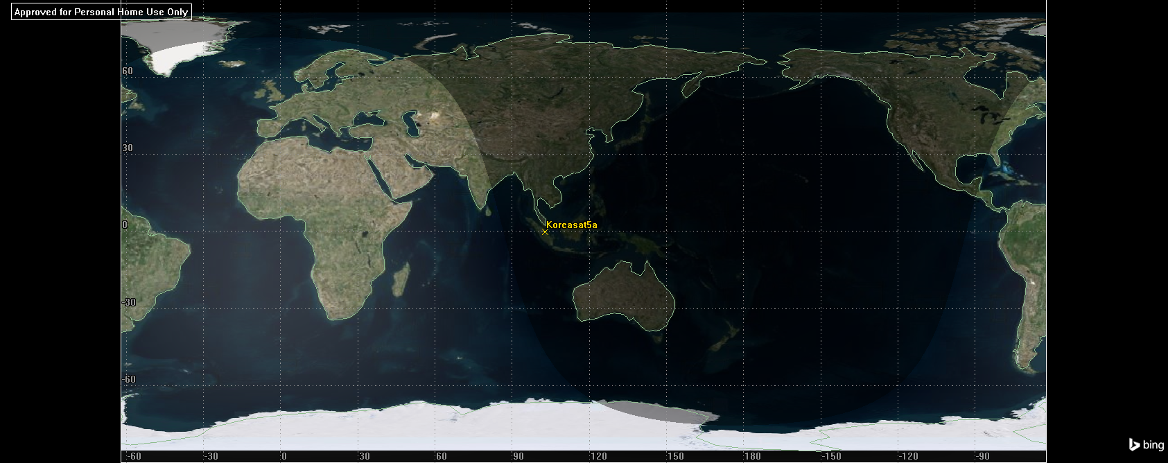

1. Results

|  |  |  |  |  |  |
| --- | --- | --- | --- | --- | --- |
|  | **Maneuver Number** | **Segment** | **Est./Act. Finite Burn Duration (sec)** | **Delta V (m/sec)** | **Fuel Used (kg)** |
|  | 1 | Transfer.Delta_V1 | 18194.974 | 2430.29365 | 3092.285 |
|  | 2 | GEO.Delta_V2_(Combined) | 6579.896 | 1837.17927 | 1118.271 |
| **Global Statistics** |  |  |  |  |  |
| Total Est./Act. Finite Burn Duration |  |  | 24774.87 |  |  |
| Total Delta V |  |  |  | 4267.47292 |  |
| Total Fuel Used |  |  |  |  | 4210.556 |

1. 3D Graphics (Overview)

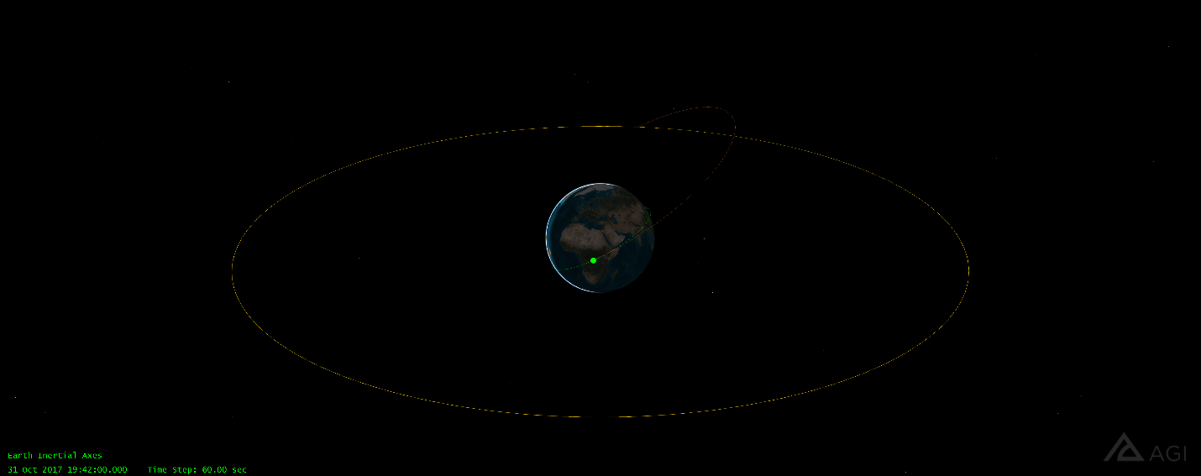

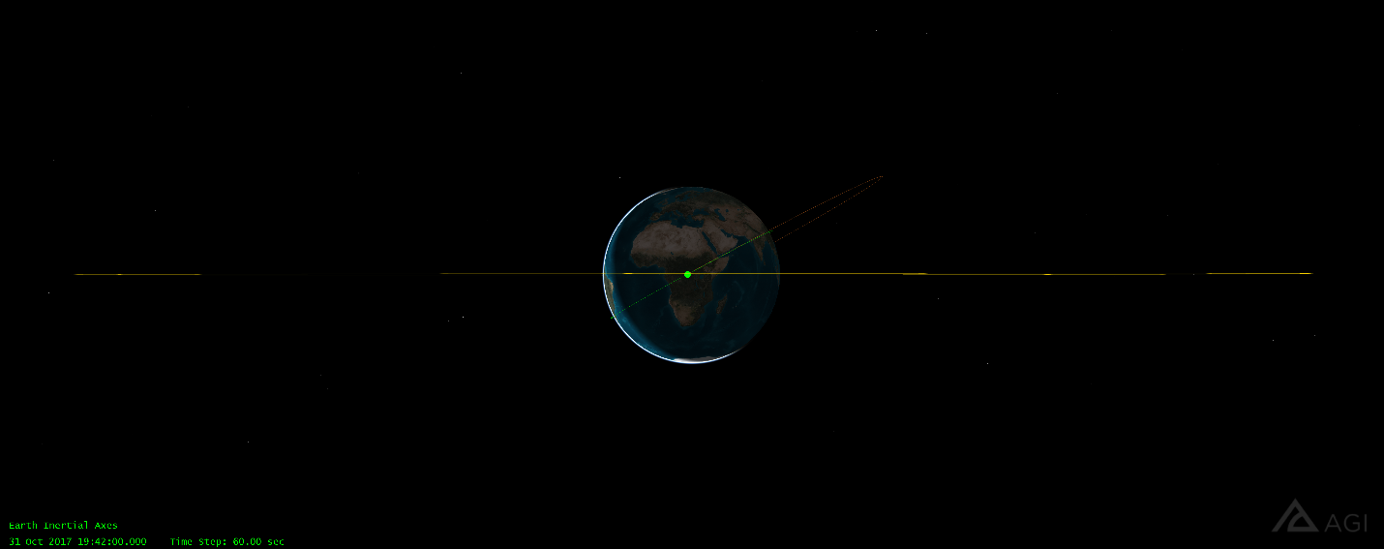

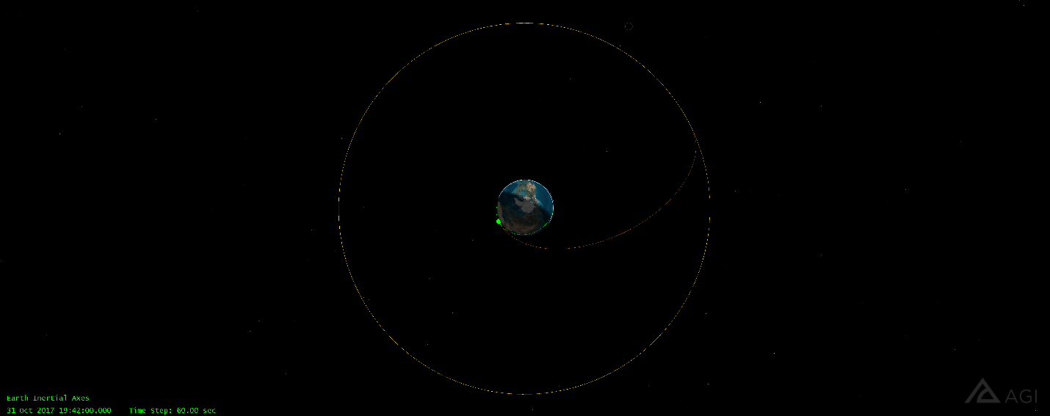

**Footnotes by Creator**

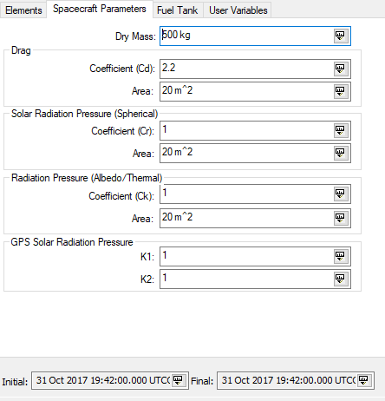Although STK is a powerful tool for modelling a mission, the team is unable to model both scenarios to the real-time results by SpaceX. The first challenge faced is the spacecraft parameters, which the default values are used in both model scenarios in *Figure 1*. The second challenge is the STK provided settings for the Central Bodies. For our team project, the Earth will be our focus and the following paragraph will mainly provide details on the gravity models and the shape used in this analysis.

*Figure 1*

The default gravity model by STK is EGM2008 Spherical Harmonics gravity field which is used with two body, J2 Perturbation and J4 Perturbation propagators. In *figure 2*, perturbations are listed in the gravity model window for reference. The default shape used is an oblate spheroid rather than a simple sphere as shown in *Figure 3*.

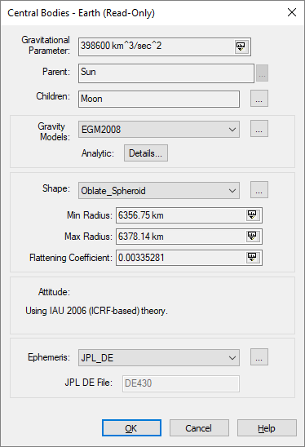 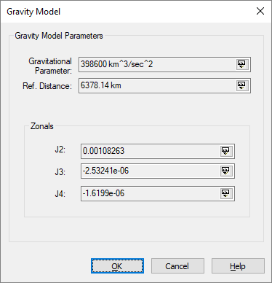

*Figure 2 Figure 3*

The listed differences of the gravity model and shape of the focused celestial body will hinder the accuracy of the Delta-V results as compared to the simple scenario modelling modelled in MATLAB which omits perturbation factors.

An approximated estimation difference in the Delta-V obtained in MATLAB will be ±100m/sec.

1. Aerospace Engineering Student, Department of Aerospace Engineering
2. Ibid
3. Ibid
4. https://www.internetworldstats.com/stats.htm
5. https://www.internetworldstats.com/stats.htm
6. https://www.internetworldstats.com/stats3.htm#asia
7. https://www.akamai.com/fr/fr/multimedia/documents/state-of-the-internet/q1-2017-state-of-the-internet-connectivity-report.pdf
8. https://net.its.hawaii.edu/history/Korean_Internet_History.pdf
9. https://sites.google.com/site/koreainternethistory/publication/brief-history-korea-eng-ver
10. https://www.thalesgroup.com/en/worldwide/space/press-release/thales-alenia-space-build-koreasat-7-and-koreasat-5a-satellites
11. http://help.agi.com/stk/index.htm#training/tq-hohmann.htm